# CHAPTER 1 INTRODUCTION

Automation is a system, method, or plan of working or controlling a methodology by electronic contraptions with decreasing human consideration to a base. The essential of building an automation structure for an office or home is extending well-ordered with different points of interest. Industrialist and experts are endeavoring to make successful and sensibility modified systems to screen and control assorted machines like lights, fans, AC reliant on the need. Automation makes a capable and a down to earth use of the power and water and decreases a noteworthy piece of the wastage. IOT provide for people and things to be related Any-time, wherever, with anyone, ideally using any framework and any organization. Automation is another basic use of IOT propels. It is the checking of the imperativeness usage and the Controlling the earth in structures, schools, work environments and recorded focuses by using different sorts of sensors and actuators that control lights, temperature, and stickiness. Here, Sensors distinguishes the movement of the living creatures and developments of the things. Sensor assumes a critical job in this task. Sensor is a gadget that is utilized to identify the adjustments in condition and send the data to different hardware, every now and again a PC processor. Also, we propose the new sagacious home circumstances reliant on the new contraptions and embedded structures. Everything thought of it as, wouldn't be a lot of an astute if it has a tendency to be more capable than a standard house.

# CHAPTER 2 LITERATURE REVIEW

A simplicity and gainful shrewd home structure is shown in this paper. This structure has two rule modules: the hardware interface module and the item correspondence module.

At the center of this structure is the Arduino UNO microcontroller which is in like manner fit for filling in as a scaled down scale web server and the interface for all the hardware modules. All correspondence and controls in this system experience the microcontroller. The insightful home structure offers feature, for instance, natural checking using the temperature, suddenness, and gas and smoke sensors. It is like manner offers changing functionalities to control lighting, fans/constrained air frameworks, and other home machines related with the hand-off structure. Another segment of this structure is the interference area which it offers using the development sensor and all these can be controlled from the Android Smartphone application or web application. In the present day, home motorization is getting the chance to be principal to enhance our life condition. Solace and effortlessness of using home machines is the thing that home roboziation is advancing. Home roboziation offers a front line way of life in which an individual finds the opportunity to control his entire house using a propelled cell phone, from turning on a TV to locking/opening doors; it in like manner offers a gainful usage of essentialness. In any case, to get or get such structure presented will cost a lot of money and that is the genuine reason of why home motorization has not gotten much premium and thought, adding to that moreover the unusualness of presenting it and organizing it. The PIR sensor is set at the way of the room portal which recognizes a man going into or leaving the room. As a man goes into the room, the counter is expanded and in like way lights switches ON by the program introduced inside the microcontroller. Additionally when a man leaves the room, the counter decremented and as requirements are microcontroller kills the light too. The lights in room are killed exactly when all individuals in the room exit and room is vacant. The test in this structure is that room door should not be adequately wide as it empowers somewhere around two people to go into the room meanwhile.

# OVERVIEW

**CHAPTER 3**

**PROBLEM DESCRIPTION**

Web of Things (IOT) is a support of keen inserted frameworks that unions the simplicity in actualizing, controlling, controlling, announcing data, exchange of information over different frameworks. In the meantime, as we are running in innovation utilizing step by step period, this task has moved to convey the command over security in our virtual nearness and normally a vitality sparing calculation over home apparatuses. Machine-to-Machine correspondence (M2M) causes us to control the required actuators. Here correspondence is

Set up between the PIR sensor and the cell phone through Internet.

# EXISTING SYSTEM

Since the evolvement of Internet of Things, individuals do pass by the side of planning the framework by actualizing GSM (Global System for Mobile correspondence) to transpond the message. Development of the System goes confused as it needs a Subscriber Identity Module to speak with the home mechanized machine.

# PROPOSED SYSTEM

Framework has been refreshed with new open source IOT Platform called Node MCU. This hardware is accessible in least expensive expense and little in size which interfaces with a system through Wi-Fi and sends a web ask. The web asks for when called, triggers a message to be sent to the customer's cell phone in this manner cautioning the person over rupture of security. Node MCU is a crucial innovation that opens the eyes of IOT to another

degree

# CHAPTER 4 SYSTEM SPECIFICATION

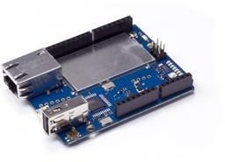

**4.1 HARDWARE REQUIREMENTS:**

**4.1.1 Passive Infrared Sensor**

Segregated infrared sensor (PIR sensor) is an electronic sensor that recognizes infrared (IR) light transmitting from things. They are every now and again used in PIR- based development locators. A dormant infrared (PIR) sensor gauges infrared light delivered from articles that make warm and in like manner infrared radiation, in its field of view. Crystalline material at the point of convergence of a square shape on the substance of the sensor recognizes the infrared radiation. At the point when the sensor is inert, the two openings recognize a comparable proportion of IR, the encompassing aggregate radiated from the room or dividers or outside. Exactly when a warm body like a human or animal travels by, it first squares one segment of the PIR sensor, which causes a positive differential change between the two sections.

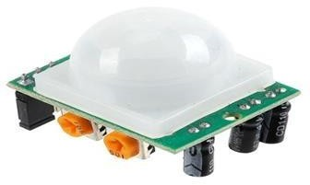

FIGURE 4.1.1 PIR SENSOR

# Arduino UNO

UNO is the microcontroller board which makes the entry level. It is the most used and documented board of the whole Arduino family. “UNO” means one in Italian.

FIGURE 4.1.2 AURDINO

# Bread board

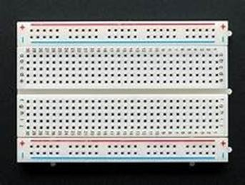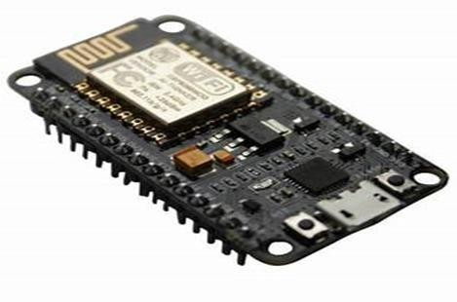

Bread board is a patch less gadget for impermanent model with hardware and test circuit plans. Its activity is to make association with wires either in sequential (even) or parallel (Vertical)

FIGURE 4.1.3 BREAD BOARD

# Node MCU

Node-mcu Is An Open Source Luau Based Firmware For The Esp8266 Wi-Fi Sac From Expressive And Utilizations An On-Module Streak Based Spiffs Record Framework. Node-mcu is Executed in C and Is Layered on The expressive Non-Oz Suk. The Firmware Was At First Created Similar To A Partner Task To The Mainstream Esp8266-Based node cu Advancement Modules, However The Undertaking Is Presently Network Bolstered, And The Firmware Would Now Be Able To Be Kept Running On Any Esp Module.

FIGURE 4.1.4 NODE MCU

**4.1.4 Bread board**

These are connecting wires, and are of three types – male to male, female to female and female to male.

FIGURE 4.1.5 JUMPER WIRES

**6. SWITCH**

In electrical designing, a switch is an electrical segment that can "make" or "break" an electrical circuit, interfering with the flow or occupying it starting with one channel then onto the next. The component of a switch expels or re-establishes the directing way in a circuit when it is worked.

FIGURE 4.1.6 SWITCH

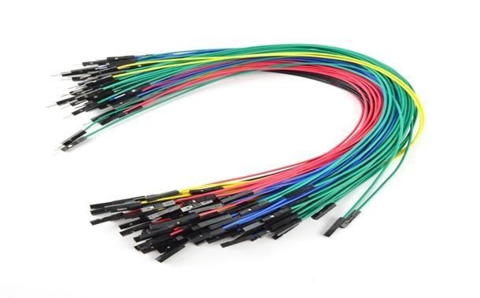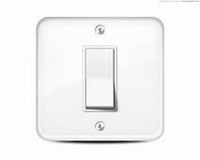

# SOFTWARE REQUIREMENTS

* + 1. Arduino (IDE) Software
    2. Processing Development Environment
    3. IFTTT (If This Then That) Mobile application

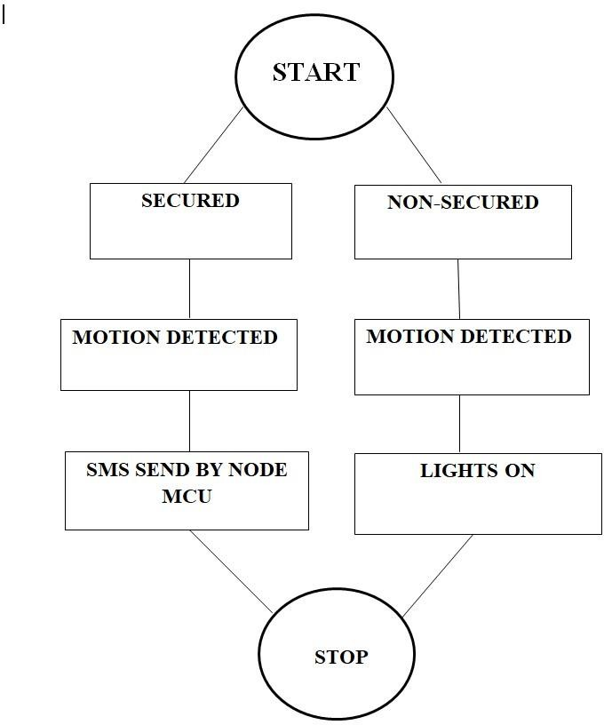

# CHAPTER 5 FLOW CHART

**CHAPTER 6 IMPLEMENTATION AND RESULT**

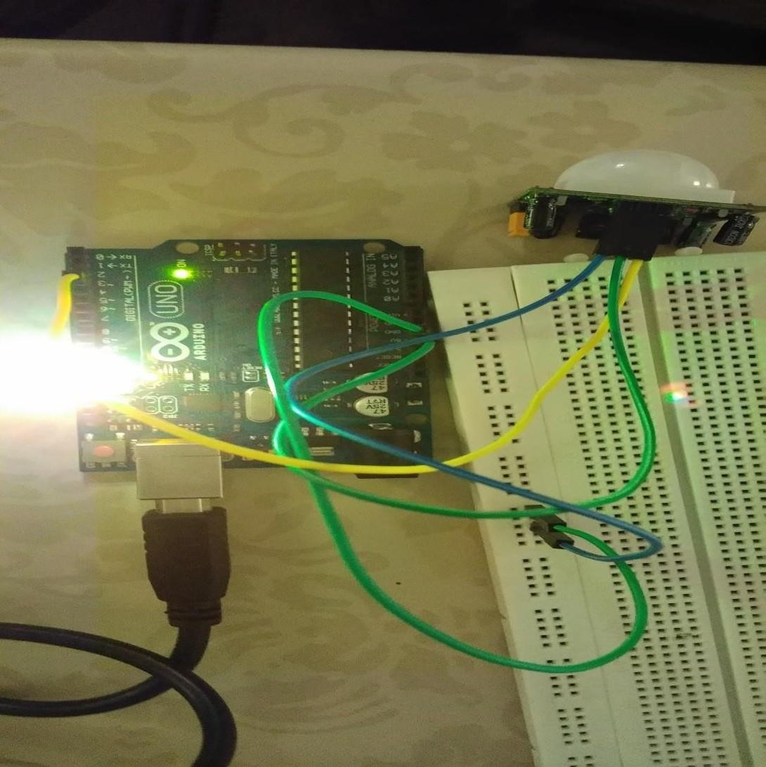

**6.1 ARDUINO SCREENSHOT**

FIGURE 6.1 ARDUINO BOARD AND PIR SENSOR

**DESCRIPTION:**

Power supply for the Arduino has been provided from PC using Arduino uno USB cable. 13th pin id Arduino is connected to the LED to ensure the transmission of output for the processed sensor data and GRD(ground) is set to GRD of Arduino.3rd pin od Arduino has been set to read the data from PIR.5v of power is allotted for sensors from the board and GRD(ground) is set to GRD of Arduino.

# 6.2 OUTPUT SCREEN

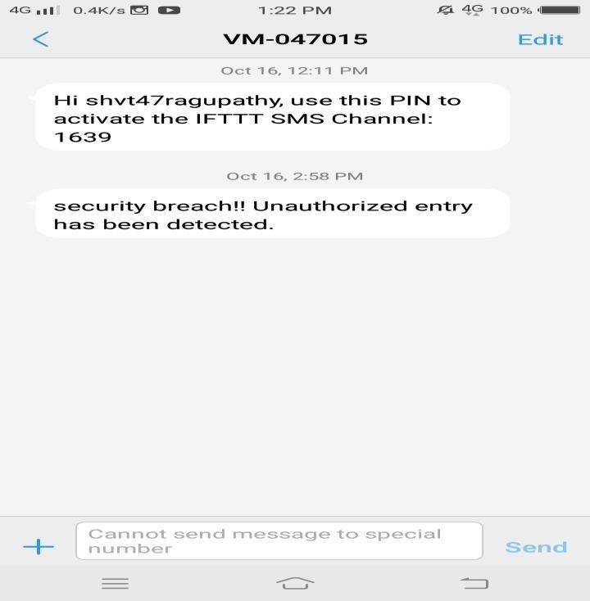

FIGURE 6.2.1VALUES OF PIR SENSOR

FIGURE 6.2.2 MESSAGE WHEN THEFT DETECTED

**6.3 SOUCRCE CODE**

#include <SoftwareSerial.h> SoftwareSerial s(5,6);

int led = 13; int sensor = 3; int state = LOW; int val = 0; int mode=HIGH; void setup() {

pinMode(led, OUTPUT); pinMode(sensor, INPUT);

s.begin(9600);

}

void loop(){ if(mode==LOW){

val = digitalRead(sensor); if (val == HIGH) {

digitalWrite(led, HIGH); delay(100);

if (state == LOW) { state = HIGH;

}

}

else {

digitalWrite(led, LOW); delay(200);

if (state == HIGH){ state = LOW;

}

}

}

if(mode==HIGH){

if (val == HIGH) { if (val == HIGH) {

digitalWrite(led, HIGH); delay(100);

}

else {

}

delay(100);

}

else {

delay(200);

}

10

}

}

**NODE MCU:**

#include <SoftwareSerial.h> SoftwareSerial s(5,6);

int led = 13;

int sensor = 3; int state = LOW; int val = 0; int mode=HIGH; void setup() {

pinMode(led, OUTPUT); pinMode(sensor, INPUT);

s.begin(9600);

}

void loop(){ if(mode==LOW){

val = digitalRead(sensor); if (val == HIGH) {

digitalWrite(led, HIGH); delay(100);

if (state == LOW) {

state = HIGH;

}

}

else {

digitalWrite(led, LOW); delay(200);

if (state == HIGH){ state = LOW;

}

}

}

if(mode==HIGH){

if (val == HIGH) { if (val == HIGH) {

digitalWrite(led, HIGH); delay(100);

}

else {

}

delay(100);

}

else {

11

delay(200);

}

}

}

# CHAPTER 7 CONCLUSION AND FUTURE WORK

As this project deals with the security of arena, internet would not be safe to control over automated machines. Thus, In future we will ensure that our work on this project will be extended to bring the concept of block chain over automated security machines that Compromise the actions to prevent leakage of data and control.

# REFERENCES

1. Takeshi Yashiro, Shinsuke Kobayashi, Noboru Koshizuka and Ken Sakamura, "An Internet of Things (IoT) Architecture for Embedded Appliances", Electrical and Control Engineering (ICECE), 2011 International Conference, Yichang, IEEE, 2011, pp. 2578-2581.
2. Vinay sagar K N, Kusuma S M Student IV SEM, M.Tech, Digital Communication. Engg, MSRIT, Bangalore, India,"Home Automation Using Internet of Things", International Research of Enginering.
3. Zhai Y., Cheng X., (2011), “Design of Smart Home Remote Monitoring System Based on Embedded System”, Control and Industrial Engineering, IEEE 2nd International Conference, pp.41-44
4. Yamazaki T., (2006), “Beyond The Smart Home”, Hybrid Information Technology, IEEE International Conference on, vol.2, pp.350-355
5. Shruti Deshinge, Prof. M. N. Kakatkar, Dept. of E\&TC, Sinhgad College of

Engineering, Pune, India,"IoT based Smart Home System for Monitoring Surrounding Condition", International Research in Computer and Communication Engineering, Vol. 4, Issue 6, June 2016.

1. Sehoon Kim, Jin-Young Hong, Seil Kim, Sung-Hoon Kim, Jun- Hyung Kim, Jake International Conference on Ubiquitous Intelligence and Computing, 2014, pp. 717-722
2. S.Sujin Issac Samuel”A Review of Connectivity Challenges in IoTSmart Home”, 3rd MEC International Conference on Big Data and Smart City, 2016
3. Mohamed Abd El-Latif Mowad, Ahmed Fathy, Ahmed Hafez,"Smart Home Automated Control System Using Android Application and Microcontroller", Scientific \& Engineering Research, Volume 5, Issue 5, May-2014
4. Subhankar Chattoraj Techno India University, Salt Lake Main Campus, EM /4 Salts

Lake,"Smart Home Automation based on different sensors and Arduino as the master Controller", Scientific and Research Publications, Volume 5, Issue 10, October 2015.

1. Abhijeet Rajurkar, Onkar Shinde, Vinayak Shinde, Bhushan Waghmode Computer Engineering, Dr D.Y. Patil School of Engineering, Pune, India, "Smart Home Control and Computer, Vol. 5, Issue 5, May 2016